1. made an year month document

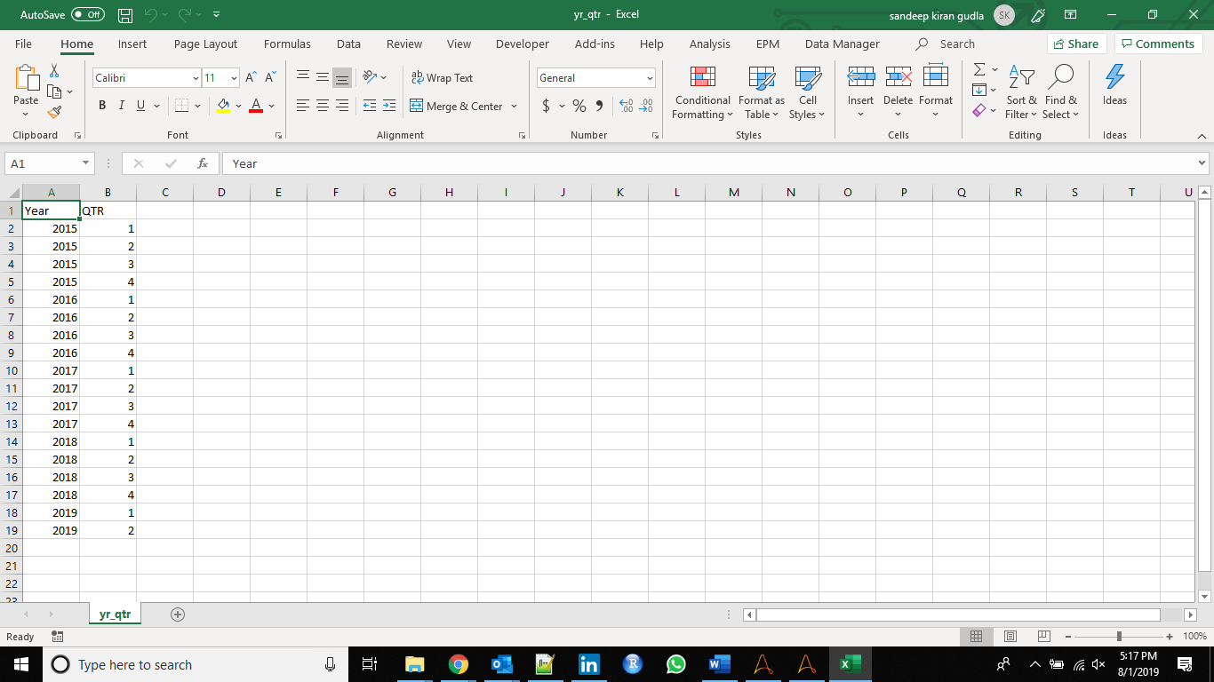

2. **form_extract** - this bot downloads the zip files from https://www.sec.gov/Archives/edgar/full-index and then downloads the zip file to local machine. It extracts the zip file and then saves in txt format.

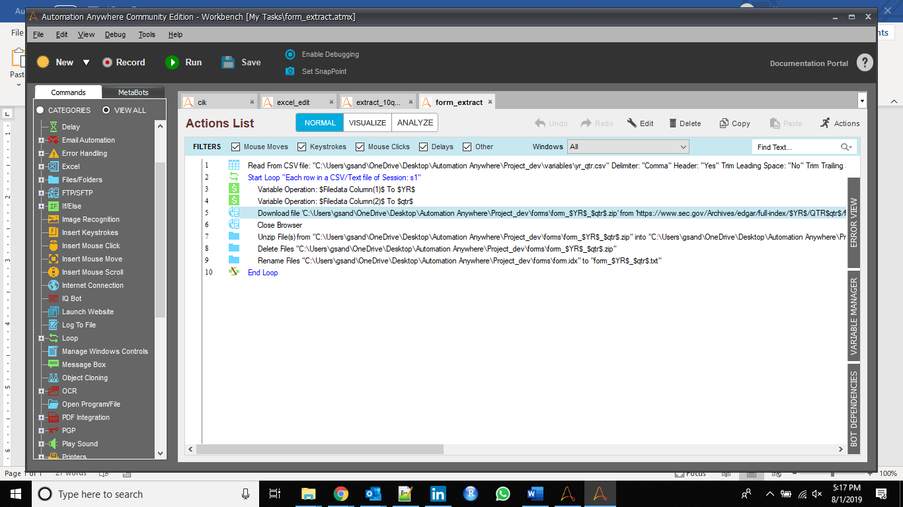



3. open_url_save_html

This bot will save the desired html file.

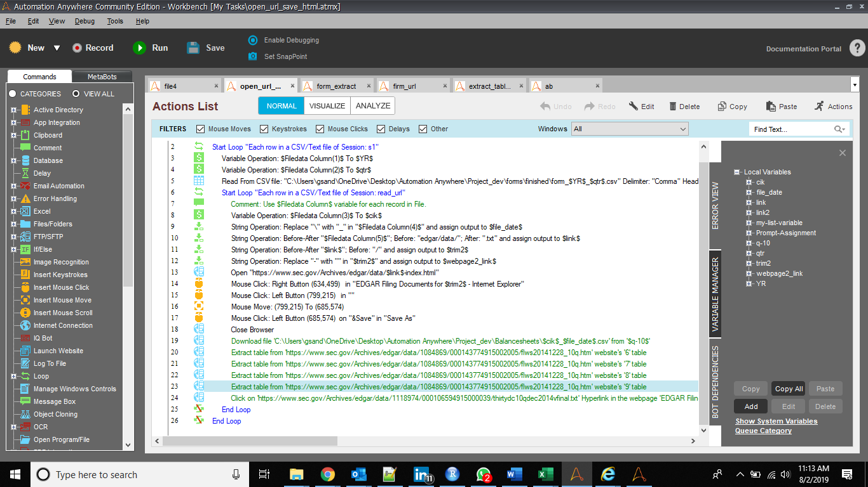

The future goals are to open the html file and get the tabular required data.